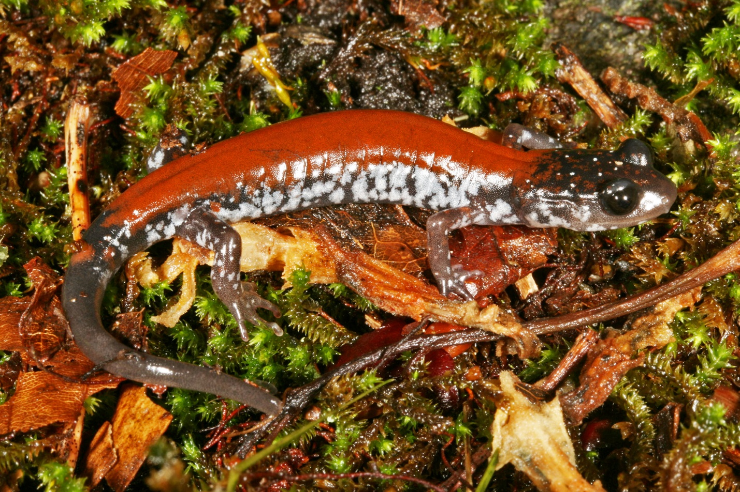
Yonahlossee salamander (Plethodon yonalohsee) in Grayson Highlands State Park, Virginia
Photo J. Lindley McKay

Olga Milenkaya
Warren Wilson College

Michael J. Adams
Amphibian Research and Monitoring Initiative
USGS Forest and Rangeland Ecosystem Science Center

Jenifer Walke
Eastern Washington University

[Include logos: USGS, ARMI, universities & colleges, SNAPS, Bsal Task Force, etc.]
Table of Contents

LEARNING OUTCOMES 1
ABSTRACT 2
INTENDED AUDIENCE & TIME 2
OUTLINE 3
DISCUSSION OF STUART et al. (2004) [Handout for Instructors] 5
COMPUTER-BASED ACTIVITY [Handout for Instructors] 8
OUTDOOR ACTIVITY WITH WILD SALAMANDERS 16
FURTHER READINGS 17
IDEAS FOR HOW TO MODIFY THIS MODULE 18
LIST OF ADDITIONAL MATERIALS THAT ARE NOT IN THIS PACKET 19
ASSESSMENT 19
THE BROADER EFFORT FOR BSAL SURVEILLANCE 19

LEARNING OUTCOMES

Note to instructors:
Skill-based outcomes address what students should be able to do, while content-based outcomes address the information that students should know. Whether the learning outcome is skill or content-based is indicated in brackets after each outcome. Also in brackets is the part of the module in which each outcome should be developed.

After successfully completing this activity, students should be able to:

- Read and interpret scientific research articles [skill][reading for homework]
- Discuss scientific research articles [skill][discussion]
- Identify the most threatened, fastest declining, and most data deficient class among the birds, mammals, and amphibians [content][reading, discussion, computer activity]
- Query the IUCN Red List for data [skill][computer activity]
- Create and interpret tables and graphs to make simple comparisons [skill][computer activity]
- Compare how the conservation status and data deficiency of vertebrate classes has changed over time [content], and propose logical reasons for any observed changes [skill][computer activity]
- Apply the scientific method to ask and answer a research question about amphibian conservation by using the IUCN Red List [skill][computer activity]
- Identify the threats facing biodiversity [content][lecture]
- Distinguish between proximate and ultimate threats [content][lecture]
- Explain how these threats affect amphibians [content][lecture]
- Identify non-native, invasive fungal pathogens (specifically Bd and Bsal) as a major threat to amphibians [content][lecture]
- Search for, and handle, wildlife in the field [skill][outdoor activity]
- Apply the sterile technique to sample live salamanders for Bsal [skill][outdoor activity]

ABSTRACT

This learning module builds on the topic of threats to biodiversity by exploring threats through the lens of a specific taxonomic group, the Class Amphibia. In particular, we focus on a current agent of decline among amphibians, the ongoing spread of the Chytridiomycosis disease. This learning module emphasizes (1) academic content about threats to biodiversity, and (2) critical skills such as the reading of scientific literature and graphing. To develop this knowledge and these skills, this module uses a variety of teaching strategies that should capture most students’ learning styles. These include reading, discussion, a computer-based activity, lecture, and a hands-on outdoor activity. Students also apply their knowledge from the classroom to a real-world conservation problem, thereby being empowered to do good in the world and to recognize their agency in doing so. During the culminating experience of this learning module, students contribute directly to an urgent conservation issue by sampling their local salamander populations for a potentially lethal, non-native and invasive fungal pathogen (Batrachochytrium salamandrivorans, or Bsal). This pathogen is yet to be detected in North America, but its introduction seems likely. Thus, the students’ sampling contributes to a broader Bsal surveillance program, one that is essential for the early detection of Bsal in North America. Early detection will then allow others to take timely, efficient, and hopefully effective action to conserve our native salamanders.

INTENDED AUDIENCE & TIME

The intended audience for is module is:
- Second- or third-year undergraduate students
- Students majoring in biology, environmental science, conservation biology, or similar discipline
- Students in a conservation biology course who have already been introduced to the threats faced by biodiversity in general
- Students who have already read at least some scientific, peer-reviewed research articles
- Students who have already been exposed to the IUCN Red List of Threatened Species

The intended class periods for this module are:
- 2 × lab class periods of 2 hours 50 minutes each
- Alternatively, in-class activities including discussion, computer-based activity, and lecture can be spread out over multiple lecture class sections ahead of one 2-hour lab period for the outdoor Bsal sampling activity

OUTLINE

Homework prior to Day 1

Assign homework Individuals work outside of class
- Read Stuart et al. (2004)
- Write at least three open-ended, discussion questions about this reading
- Bring the article, questions, and a laptop with you to class

Day 1: Indoor activities During 2 hour 50 min lab period

Group discussion of Stuart et al. (2004) 30 minutes
- Divide students into small groups (e.g., 4 students / group)
- Students discuss the article using their own questions and a set of questions that you can provide to them before or during their discussion (see page X)

Computer-based activity 2 hour 20 min
- Students are guided by a handout to: (2 hours)
  - Tabularize & visualize data from Stuart et al. (2004) to compare the conservation status and data deficiency between amphibians, mammals, and birds
  - Update the findings of Stuart et al. (2004) with data from the IUCN Red List
  - Compare status of amphibians, mammals, and birds between 2004 to today
  - Compare the IUCN threats today between amphibians, mammals, and birds
  - Generate a novel question about the conservation of amphibians, and use data from the IUCN Red List to answer their question (done in pairs)
- Wrap-up as a whole class (20 minutes)
  - Ask students to report back their novel questions and findings
  - Review key findings:
    - Amphibians are more threatened and more data deficient than either birds or mammals
    - This scenario has not changed since the early 2000, except that mammals are much more data deficient now than they were in the early 2000 (discuss).
    - Based on Stuart et al. (2004), amphibians are primarily threatened by habitat loss, over exploitation, and “enigmatic” threats. Based on the IUCN Red List today, of the known threats, they are primarily threatened by biological resource use and agriculture (same as mammals and birds). But these are just the known threats, what were the enigmatic threats discussed in Stuart et al. (2004)?
    - Brainstorm as a class what these enigmatic threats could be and tease the class that this will be revealed in their homework.
Homework prior to Day 2

Assign homework Individuals work outside of class
- Read Scheele et al. (2019)
- Bring the article with you to class
- Dress appropriately for field work, bring a water bottle, etc.

Day 2: Lecture & outdoor activity During 2 hour 50 min lab period

Lecture 30 minutes
- Review the paradigm of proximate and ultimate threats
- Review each type of proximate threat as applied to amphibians through case studies
- In the section about invasive species and disease, provide the background of Bd and Bsal
- Incorporate Scheele et al. (2019) as a follow-up to Stuart et al. (2004)
- Explain that threats can act in synergy with each other, and brainstorm how that could be the case with amphibians
- Explain the current and ongoing effort for Bsal surveillance in North America
- Describe the sampling procedures that they are about to do

Outdoor activity with wild salamanders 2 hours 20 minutes
[We’ll need to add information here to outline how to do the field sampling]

DISCUSSION OF STUART et al. (2004) [Handout for Instructors]

Stuart SN, JS Chanson, NA Cox, BE Young, ASL Rodrigues, DL Fischman, RW Waller. 2004. Status and Trends of Amphibian Declines and Extinctions Worldwide. Science 306(5702):1783—1786.

In small groups, discuss the article above. You can use the discussion questions that you wrote and the questions below to facilitate your discussion.

- What did you find confusing in the article?

[Here, students can engage in peer-to-peer learning to get clarifications from each other about what they didn’t fully understand on their own, so that they are better prepared to engage with the rest of the discussion]

- What is meant by “globally threatened”?
“Globally threatened” = IUCN categories Vulnerable + Endangered + Critically Endangered

- How do amphibians compare to birds and mammals in terms of being …

Globally threatened:

Amphibians are more threatened than either birds or mammals:
- 32.5% of amphibian species are threatened
- Amphibians are nearly three times as threatened as birds (12% of bird species are threatened)
- Amphibians are also more threatened than mammals (23% of mammal species are threatened)

Critically endangered:
A higher proportion of amphibians are critically endangered compared to either birds or mammals: 7.4% of amphibians are critically endangered compared to 3.8% for mammals, and only 1.8% for birds

Data deficient:
A higher proportion of amphibians are data deficient compared to either birds or mammals

- Describe population trends of amphibians.

Not good: >40% are declining, 1/3 stable, and another 1/3 is unknown. This means that current estimate of declining is actually an underestimate.

- What are the three main threats to amphibians globally?

- Habitat loss

- Over exploitation

- Unknown: “Enigmatic decline”

- Discuss each figure. For each figure, write in complete sentences to state the key results.

Figure 1.

Threats to amphibians are not randomly distributed around the planet. The threat of reduced habitat is concentrated in Europe, parts of the USA, west Africa, and Borneo, while overexploitation is concentrated in east Asia. Meanwhile, enigmatic declines are the primary threat in Central and northern South America and parts of Australia.

Figure 2.

There is a negative correlation between the number of species in a family of amphibians and the percent of those species that are rapidly declining. That is, families with few species are most likely to have more of those species rapidly declining.

Figure 3.

The percent of species that are rapidly declining and facing particular threats are not randomly distributed among the various families of amphibians. That is, some families are more declining faster than others, and some are particularly vulnerable to specific threats over other threats.

- Brainstorm as many ideas as you can to answer this question: what could be causing these “enigmatic declines”?

e.g., previously unknown pollutant, climate change, cat predation, hole in the ozone layer is causing UV damage, trophic cascades from extinctions of insect prey, other

- As a conservation biologist, what would be your next steps? Discuss your ideas for what should be done next. Of all the ideas your group comes up with, write three of your favorite ideas here: what is your idea, and why is this the best next step?

Ideas should be for both scientific research and actions that practitioners can take to highlight that conservation biology requires both pure and applied science.

- Research into what constitutes the enigmatic threats. Conservationists need to identify precisely the agent of decline to take action.
- Stop over-exploitation in East and South East Asia as this seems like the most obvious, and direct way to cease extinctions. This may require legislation, policy, PR campaigns to change consumer demand for pets from western countries and consumer demand for food in eastern countries, etc.
- Buy, conserve, and restore land to prevent extinctions among those threatened with habitat loss.
- Research into fungal diseases because the article mentioned this as one of the likely causes of enigmatic declines.
- Captive breeding programs of rapidly declining species to “buy time” because it is impossible to stop enigmatic declines without understanding the agent of decline, and therefore captive breeding programs can provide the time needed to understand and take action on enigmatic declines.
- Other…

COMPUTER-BASED ACTIVITY [Handout for Instructors]

Prior to this activity

- Read Stuart et al. (2004) and write three discussion questions about this reading
- Discuss Stuart et al. (2004) in small groups during class
- Bring a laptop with you to lab that can connect to the campus Wi-Fi

Introduction

To follow-up on your reading and discussion of Stuart et al. (2004), we will now tabularize and visualize the data in that article, add current data from the IUCN Red List, and make comparisons between different taxonomic groups and time periods.

In this computer-based activity, you will work individually and in pairs to:
- Compare the conservation status and data deficiency between amphibians, mammals and birds based on the data in Stuart et al. (2004).
- Update our knowledge with data from the IUCN Red List and compare the situation for these taxa between 2004 and today.
- Compare the current threats that amphibians, birds, and mammals are facing based on the IUCN Red List.
- Use the scientific method to ask and answer a novel research question about amphibian conservation.
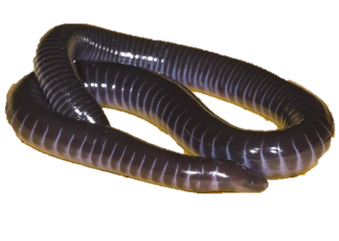

Caecilians
Order Gymnophiona

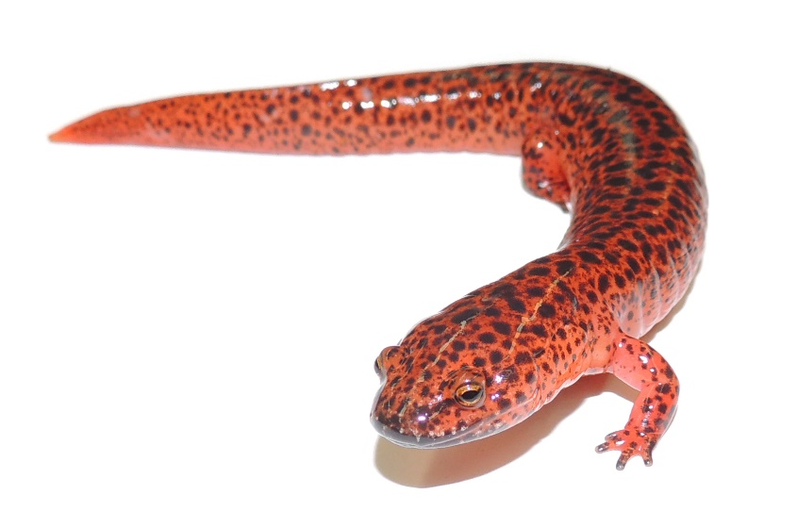

Frogs
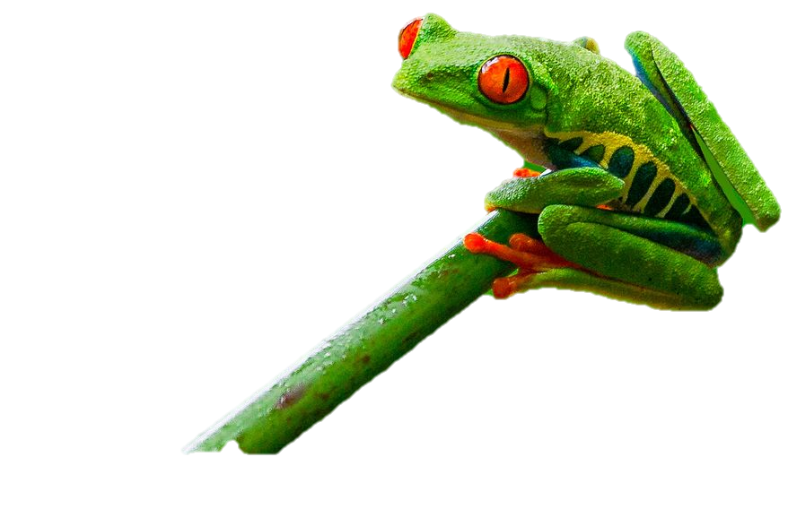
Order Anura

Salamanders
Order Caudata
STEP1: Complete Table 1
You can find some of the data in the text of Stuart et al. (2004), Table S2 from the supplementary materials for Stuart et al. (2004), and on the IUCN Red List (https://www.iucnredlist.org/). You will also need to make some calculations yourself.

Table 1. Number (#) and percent (%) of amphibian, bird, and mammal species that are extant (Total Species), critically endangered, globally threatened, and data deficient between different time periods. Round the percentages (%) to one tenth of a percent.

 | Amphibians |  |  |  |  |  |  | Birds |  |  |  |  | Mammals
 | 1980 |  | 2004 |  | 2020 |  |  | 2004 |  | 2020 |  |  | 2004 |  | 2020
 | # | % | # | % | # | % |  | # | % | # | % |  | # | % | # | %
Total Species | 5743³ | 100 | 5743⁴ | 100 | 6756⁵ | 100 |  | 10092 | 100 | 11126⁵ | 100 |  | 4913 | 100 | 5792⁵ | 100
Critically Endangered | 231³ | 4.0 | 427⁴ | 7.4 | 567⁵ | 8.4 |  | 179⁴ | 1.8 | 224⁵ | 2.0 |  | 184⁴ | 3.8 | 202⁵ | 3.5
Globally Threatened | 1772³ | 30.9 | 1856⁴ | 32.5 or 32.3¹ | 2123^{2,5} | 31.4 |  | 1211⁴ | 12 | 1492² | 13.4 |  | 1130⁴ | 23 | 1223^{2,5} | 21.1
Data Deficient | 1302³ | 22.7 | 1294⁴ | 22.5 | 1443⁵ | 21.4 |  | 78⁴ | 0.8 | 56⁵ | 0.5 |  | 256⁴ | 5.3 | 855⁵ | 14.8

Notes to instructor
¹ Amphibian % in 2004 is written as 32.5% in the text of Stuart et al. (2004), but this seems to be a typo because it should actually be 1856/5743*100 = 32.3%.
² Globally threatened species for 2019 is calculated as number of Vulnerable + Endangered + Critically Endangered species based on the IUCN Red List.
³ Number of amphibians in 1980 is from Table S2 in the supplementary materials of Stuart et al. (2004).
⁴ Numbers of species in 2004 are from the text of Stuart et al. (2004), except for the total number of bird and mammal species which should be calculated by the students (for example, total species of birds = 1211/(12/100) = 10092).
⁵ Number of species for 2019 should all be gathered from searching the IUCN Red List, and the % for 2019 is then calculated by the students.
STEP 2: Make a graph of Table 1
Visualize the results from Table 1 by drawing three graphs that compare the different taxonomic groups, over different time periods, for their status as threatened, critically endangered, and data deficient. Label the axes, write a caption to describe the graph, and create a legend.

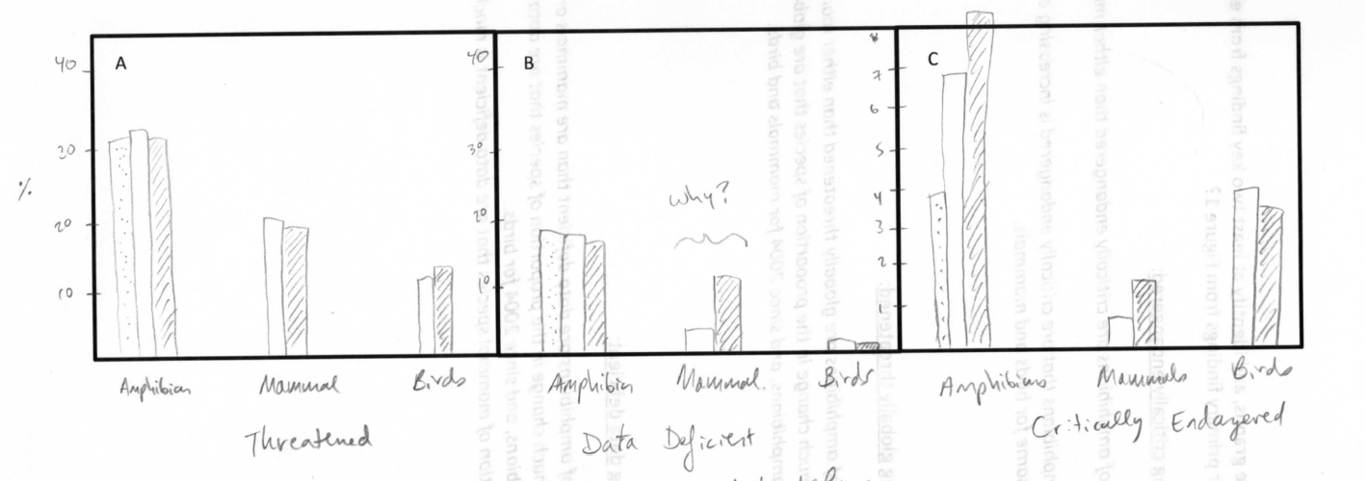

Figure 1. A comparison among amphibians, mammals, and birds for the percent of species that are globally
LEGEND
Threatened (A), data deficient (B), and critically endangered (C).

STEP 3: Identify key results
Turn to a neighbor, compare graphs, and identify at least two key findings from each of your three graphs. What are your primary findings from Figure 1?

Regarding the status of being critically endangered:

- A higher proportion of amphibians are critically endangered than either mammals or birds.
- The proportion of amphibians that are critically endangered is increasing over time, but staying roughly the same for birds and mammals.

Regarding the status of being globally threatened:

- A higher proportion of amphibians are globally threatened than either mammals or birds
- There has not been much change in the proportion of species that are globally threatened since the 1980’s for amphibians, and since 2004 for mammals and birds.

Regarding the status of being data deficient:

- A higher proportion of amphibians are data deficient than are mammals or birds.
- There has not been much change in the proportion of species that are data deficient since the 1980’s for amphibians, and since 2004 for birds.
- However, the proportion of mammal species that are data deficient is much higher today than it was in 2004.

STEP 4: Complete Table 2
Stuart et al. (2004) identified three key threats to amphibians worldwide: habitat loss, over exploitation, and enigmatic threats. The IUCN Red List uses 12 categories for threats (see list in Table 2 below). Before completing Table 2, discuss with a neighbor to predict which threat you think is currently the most important:

I predict that the most impactful threat for amphibians is ______________________________.

… for birds is ______________________________.

… for mammals is ______________________________.

Complete Table 2 by using the IUCN Red List to gather data and then make some calculations yourself. Round the percentages to the nearest tenth of a percent.

Table 2. The number of species that are affected by each threat among amphibians, birds and mammals (# of species); and a weighting of the importance of each threat based on its contribution as a percent of all threats (% of all threats).

 | Amphibians |  | Birds |  | Mammals
Threats | # of species | % of all threats | # of species | % of all threats | # of species | % of all threats
1 - Development | 2,144 | 15.3 | 696 | 7.0 | 12,963 | 11.2
2 - Agriculture, aquaculture | 3,649 | 26.0 | 2,166 | 21.9 | 22,326 | 19.3
3 - Energy & mining | 489 | 3.5 | 482 | 4.9 | 5,457 | 4.7
4 - Transportation | 330 | 2.3 | 398 | 4.0 | 3,983 | 3.4
5 - Biological resource use | 3,165 | 22.5 | 2,321 | 23.4 | 26,112 | 22.6
6 - Human intrusion, disturbance | 281 | 2.0 | 249 | 2.5 | 4,339 | 3.7
7 - Natural system modification | 1,049 | 7.5 | 790 | 8.0 | 12,527 | 10.8
8 - Invasive species, disease | 1,264 | 9.0 | 1,084 | 10.9 | 9,453 | 8.2
9 - Pollution | 1,195 | 8.5 | 467 | 4.7 | 9,966 | 8.6
10 - Geological events | 67 | 0.5 | 44 | 0.4 | 695 | 0.6
11 - Climate change, weather | 407 | 2.9 | 1,191 | 12.0 | 7,586 | 6.6
12 - Other | 3 | 0.0 | 14 | 0.1 | 343 | 0.3
Total # of threats | 14,043 | 100 | 9,902 | 100 | 115,750 | 100

STEP 5: Identify key results & discuss
Turn to a neighbor, compare your Table 2 to theirs and complete the following questions.

Why are there more “Total # of threats” than there are species?

Because each species is often threatened by more than on threat. Therefore, the number of threats is going to be more than the number of species.

What are the primary and secondary threats for each taxonomic group?

Taxa Primary Threat Secondary Threat

Amphibians _2 - Agriculture & aquaculture__ _5 - Biological resource use__

Birds _5 - Biological resource use___ _2 - Agriculture & aquaculture

Mammals _5 - Biological resource use___ _2 - Agriculture & aquaculture

Why are these three different groups of animals affected so much by the same two threats?

Because agriculture and biological resource use often affect habitat, and habitat issues remain the primary threat across taxa: agriculture changes and destroys habitat, biological resource use in terms of logging also changes and destroys habitat, and all non-generalist species would be sensitive to this regardless of whether they are amphibians, birds or mammals.

Note that the current IUCN data do not include enigmatic threats because it only documents known threats. What about the enigmatic threats faced by amphibians? Discuss with your neighbor and brainstorm as many things as possible that could be causing the enigmatic declines as described in Stuart et al. (2004):

e.g., feral cat predation, a previously unknown pollutant, plastic ingestion, UV radiation from depleted ozone layer, trophic cascade from loss of insect prey species, loss of mutualism with beneficial microbiome, introduction of novel pathogen or predator or competitor, other…
STEP 6: Ask and answer a novel research question
With your neighbor, follow the scientific method to ask and answer a novel research question.

Observation Make an observation about the conservation of amphibians. Draw from this handout, Stuart et al. (2004), or prior knowledge.

e.g., Some amphibian species are already extinct (IUCN Red List)

Question Ask a research question that you can answer with the data available in the IUCN Red List.

e.g., Was the geographic distribution of these extinctions random?

Hypothesis Write a hypothesis that is your answer to the question.

e.g., No, amphibian extinctions have not been geographically random and were mostly in developed rather than less developed countries because I presume that developed countries have had the most habitat loss.

Prediction Write a prediction of what you expect your result to be if your hypothesis is true. Write this prediction in the following format “If I do X, then Y should be the result.” For example, “If I compare the percentage of amphibian species that are threatened between different orders, then the frogs will have a higher percentage of threatened species compared to amphibians and caecilians.”

e.g., If I categorize each extinct amphibian in the IUCN Red List as being from either a “developed” or “less developed” country and compare the percentage of extinct species between these two categories, then there will be a higher percentage of extinct species in developed than less developed countries.
Test Write brief bulleted notes to outline your procedure. What will you do to test your hypothesis?

E.g.,
- Make a spreadsheet of the number of extinct amphibians from the IUCN Red List by country
- Categorize each country as being either “developed” or “less developed”
- Calculate the percent of extinct species that were from developed and less developed countries, and compare

Write one or two complete sentences to state your key result(s).

E.g., Most extinct amphibian species were from less developed countries (X%), compared to only Y% of extinct species that were from developed countries.

Conclusion Write one or two complete sentences to explain what your results mean.

E.g., The extent of development had the opposite effect on extinction than I had predicted because less developed countries accounted for the majority of extinct species. This suggests that economically less-developed countries still create threats to amphibians (e.g., land clearing) and indeed, are more threatening to amphibians (perhaps because developed countries export their environmental cost to less developed countries through international trade or because of weaker environmental regulations or enforcement of environmental laws, or other reasons).

Repeat As a scientist, what should be your next step? Propose a follow-up study.

E.g., What are the primary threats in these less developed countries that led to amphibian extinctions? Use the IUCN Red List to identify the primary threats to amphibians in those countries that had amphibian extinctions in the past.

OUTDOOR ACTIVITY WITH WILD SALAMANDERS

[Provide protocols & instructions here for how to prepare before going outdoors, what they will do outside for catching & sampling salamanders, and what to do upon returning (e.g., data entry & sample storage). This section will be written pending final decisions about sampling protocols.]

FURTHER READINGS

Disease as a Threat to Biodiversity:

Fisher et al. 2012. Nature (https://www.nature.com/articles/nature10947)
Daszak et al. 2000. Science (DOI: 10.1126/science.287.5452.443d)
Smith et al. 2009. Animal Conservation (https://doi.org/10.1111/j.1469-1795.2008.00228.x)

Chytridiomycosis Disease as a Threat to Amphibians:

Berger et al. 1998. PNAS
Schloegel et al. 2006. EcoHealth
Skerratt et al. 2007. EcoHealth
Voyles et al. 2009. Science
Kilpatrick et al. 2010. TREE
Gillespi et al. 2015. Animal Conservation
O’Hanlon et al. 2018. Science
Scheele et al. 2019. Science
Russell et al. 2019. Biological Conservation 236(296-304)

Batrachochytrium salamandrivorans (Bsal):

Martel et al. 2013. PNAS
Martel et al. 2014. Science
Blooi et al. 2015. Scientific Reports
Grant et al. 2015. USGS Open Report (https://doi.org/10.3133/ofr20151233)
Klocke et al. 2017. Nature
Richgels et al. 2016. Royal Society Open Science
A North American Strategic Plan to Control Invasions of the Lethal Salamander Pathogen Batrachochytrium salamandrivorans. North American Bsal Task Force.

Useful online resources:

www.salamanderfungus.org
https://amphibiandisease.org

IDEAS FOR HOW TO MODIFY THIS MODULE

For an emphasis on higher quantitative skills:
- During the part of the computer-based activity where students ask and answer their own questions using IUCN Red List data, help students to develop questions that will require statistical analysis. This portion of the activity can then be expanded into a short homework assignment, or expanded analysis and writing assignment.

For developing table & graphing software skills:
- During the computer-based activity, students can create their own spread sheets and then generate graphs in Excel, R, or other software.
For more advanced students:
- [xxx]
For less advanced students:
- [xxx]
For students who have not yet been exposed to the IUCN Red List:
- [xxx]
For students who have not yet read scientific research articles:
- [xxx]
For a shorter time period:
- [xxx]
For a longer time period:
- [xxx]

LIST OF ADDITIONAL MATERIALS THAT ARE NOT IN THIS PACKET

- Copies of Stuart et al. (2004) and Scheele et al. (2019)
Note that both include color figures and are therefore best distributed to students as either digital copies or hard copies printed in color.

- Lecture PowerPoint
This includes suggested text in the comments section of each slide. You are welcome to modify this PowerPoint to suite your course. PowerPoint is made available to instructors at [xxxxx].

- Supplies for Bsal surveillance
[We will need to include some information here, or elsewhere, about which supplies we will provide, which supplies they will need to provide themselves, how to order supplies, etc.]

ASSESSMENT

[We may choose to include some questions here for a pre- and post-test that could be used for assessment of this module.]

THE BROADER EFFORT FOR BSAL SURVEILLANCE

Thank you for participating in Bsal surveillance! Your efforts through this learning module, “Threats to Amphibians,” is contributing to the broader effort for the early detection of Bsal in North America. Early detection will allow for a more speedy, efficient and effective response.

“Threats to Amphibians” is one of several learning modules developed for the Student Network for Amphibian Pathogen Surveillance (SNAPS), a nation-wide program of the Bsal Surveillance Working Group. The National Bsal Task Force includes this and other working groups, each addressing separate facets of the conservation effort in response to the likely introduction of Bsal.

[We’ll need to work on this section. I’m not sure how detailed we want to get here.]

