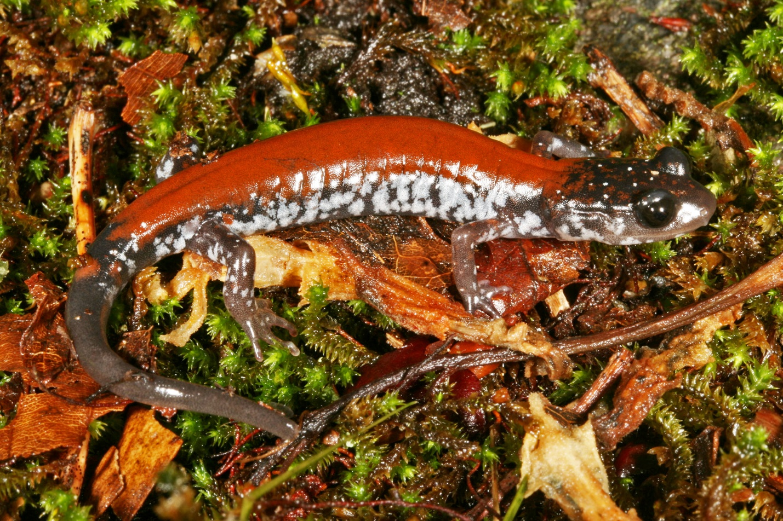
Yonahlossee salamander (Plethodon yonalohsee) in Grayson Highlands State Park, Virginia
Photo J. Lindley McKay

Olga Milenkaya
Warren Wilson College

Michael J. Adams
Amphibian Research and Monitoring Initiative
USGS Forest and Rangeland Ecosystem Science Center

Jenifer Walke
Eastern Washington University

[Include logos: USGS, ARMI, universities & colleges, SNAPS, Bsal Task Force, etc.]
Table of Contents

LEARNING OUTCOMES 1
OUTLINE 2
DISCUSSION OF STUART et al. (2004) 3
COMPUTER-BASED ACTIVITY 6
OUTDOOR ACTIVITY WITH WILD SALAMANDERS 14
FURTHER READINGS 15
THE BROADER EFFORT FOR BSAL SURVEILLANCE 16

LEARNING OUTCOMES

After successfully completing this activity, students should be able to:

- Read and interpret scientific research articles
- Discuss scientific research articles
- Identify the most threatened, fastest declining, and most data deficient class among the birds, mammals, and amphibians
- Query the IUCN Red List for data
- Create and interpret tables and graphs to make simple comparisons
- Compare how the conservation status and data deficiency of vertebrate classes has changed over time, and propose logical reasons for any observed changes
- Apply the scientific method to ask and answer a research question about amphibian conservation by using the IUCN Red List
- Identify the threats facing biodiversity
- Distinguish between proximate and ultimate threats
- Explain how these threats affect amphibians
- Identify non-native, invasive fungal pathogens (specifically Bd and Bsal) as a major threat to amphibians
- Search for, and handle, wild salamanders in the field
- Apply the sterile technique to sample live salamanders for Bsal

OUTLINE

Our primary purpose is to dive deeper into the threats that biodiversity faces by examining these threats through the lens of a specific taxonomic group, the Class Amphibia. We will learn about the conservation status of amphibians and their primary threats, and then contribute to a broader effort to address a particularly urgent threat among our native salamanders.

Homework due before Day 1

Complete the following before coming to class
- Read Stuart et al. (2004)
- Write at least three open-ended, discussion questions about this reading
- Bring the article, your questions, and a laptop with you to class

Day 1: Indoor activities

Group discussion of Stuart et al. (2004)
- Students will be divided into small groups to discuss the reading
- You can use your discussion questions and the questions provided by your instructor to facilitate the discussion

Computer-based activity
- You will work both individually and in a pair on a computer-based activity
- Wrap-up as a whole class to summarize and discuss key findings

Homework due before Day 2

Complete the following before coming to class
- Read Scheele et al. (2019)
- Bring the article with you to class
- Dress appropriately for field work, bring a water bottle, etc.

Day 2: Lecture & outdoor activity

Lecture
- Lecture about threats to amphibians
- Instructions for field trip and Bsal sampling

Outdoor activity with wild salamanders
- As a class, you will search for wild salamanders in the field and apply sterile technique to sample them for Bsal

DISCUSSION OF STUART et al. (2004)

Stuart SN, JS Chanson, NA Cox, BE Young, ASL Rodrigues, DL Fischman, RW Waller. 2004. Status and Trends of Amphibian Declines and Extinctions Worldwide. Science 306(5702):1783—1786.

In small groups, discuss the article above. You can use the discussion questions that you wrote and the questions below to facilitate your discussion.

- What did you find confusing in the article?
- What is meant by “globally threatened”?

- How do amphibians compare to birds and mammals in terms of being …

Globally threatened:

Critically endangered:

Data deficient:

- Describe population trends of amphibians.

- What are the three main threats to amphibians globally?

- _____________________________________

- _____________________________________

- _____________________________________

- Discuss each figure. For each figure, write in complete sentences to state the key results.

Figure 1.

Figure 2.

Figure 3.

- Brainstorm as many ideas as you can to answer this question: what could be causing these “enigmatic declines”?

- As a conservation biologist, what would be your next steps? Discuss your ideas for what should be done next. Of all the ideas your group comes up with, write three of your favorite ideas here: what is your idea, and why is this the best next step?

COMPUTER-BASED ACTIVITY

Prior to this activity

- Read Stuart et al. (2004) and write three discussion questions about this reading
- Discuss Stuart et al. (2004) in small groups during class
- Bring a laptop with you to lab that can connect to the campus Wi-Fi

Introduction

To follow-up on your reading and discussion of Stuart et al. (2004), we will now tabularize and visualize the data in that article, add current data from the IUCN Red List, and make comparisons between different taxonomic groups and time periods.

In this computer-based activity, you will work individually and in pairs to:
- Compare the conservation status and data deficiency between amphibians, mammals and birds based on the data in Stuart et al. (2004).
- Update our knowledge with data from the IUCN Red List and compare the situation for these taxa between 2004 and today.
- Compare the current threats that amphibians, birds, and mammals are facing based on the IUCN Red List.
- Use the scientific method to ask and answer a novel research question about amphibian conservation.
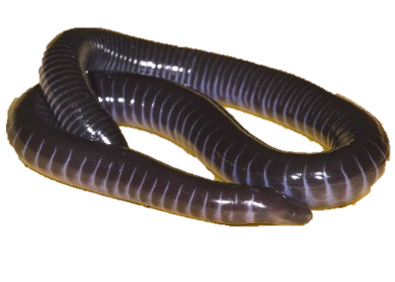

Caecilians
Order Gymnophiona

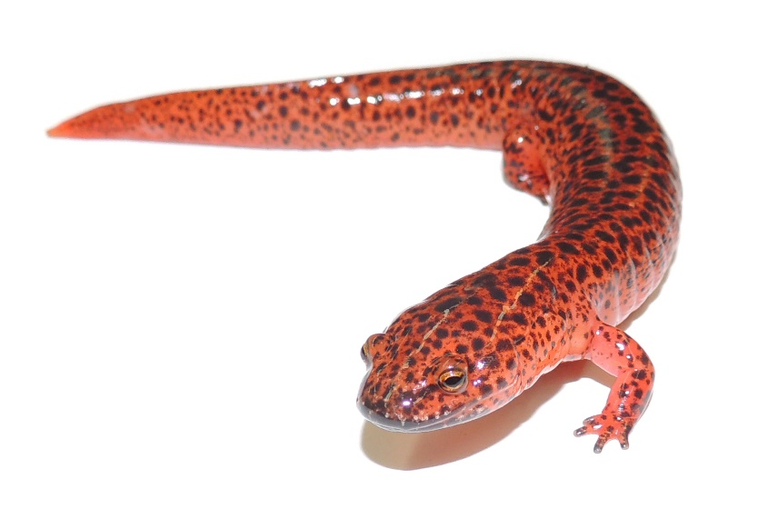

Frogs
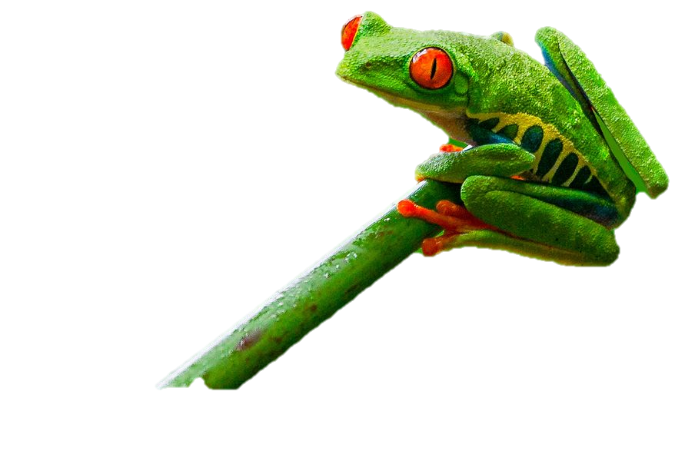
Order Anura

Salamanders
Order Caudata

STEP1: Complete Table 1
You can find some of the data in the text of Stuart et al. (2004), Table S2 from the supplementary materials for Stuart et al. (2004), and on the IUCN Red List (https://www.iucnredlist.org/). You will also need to make some calculations yourself.

Table 1. Number (#) and percent (%) of amphibian, bird, and mammal species that are extant (Total Species), critically endangered, globally threatened, and data deficient between different time periods. Round the percentages (%) to one tenth of a percent.

 | Amphibians |  |  |  |  |  |  | Birds |  |  |  |  | Mammals
 | 1980 |  | 2004 |  | 2020 |  |  | 2004 |  | 2020 |  |  | 2004 |  | 2020
 | # | % | # | % | # | % |  | # | % | # | % |  | # | % | # | %
Total Species | 5743³ | 100 | 5743⁴ | 100 | 6756⁵ | 100 |  | 10092 | 100 | 11126⁵ | 100 |  | 4913 | 100 | 5792⁵ | 100
Critically Endangered | 231³ | 4.0 | 427⁴ | 7.4 | 567⁵ | 8.4 |  | 179⁴ | 1.8 | 224⁵ | 2.0 |  | 184⁴ | 3.8 | 202⁵ | 3.5
Globally Threatened | 1772³ | 30.9 | 1856⁴ | 32.5 or 32.3¹ | 2123^{2,5} | 31.4 |  | 1211⁴ | 12 | 1492² | 13.4 |  | 1130⁴ | 23 | 1223^{2,5} | 21.1
Data Deficient | 1302³ | 22.7 | 1294⁴ | 22.5 | 1443⁵ | 21.4 |  | 78⁴ | 0.8 | 56⁵ | 0.5 |  | 256⁴ | 5.3 | 855⁵ | 14.8

STEP 2: Make a graph of Table 1
Visualize the results from Table 1 by drawing three graphs that compare the different taxonomic groups, over different time periods, for their status as threatened, critically endangered, and data deficient. Label the axes, write a caption to describe the graph, and create a legend.

C
B
A

Figure 1.
LEGEND

STEP 3: Identify key results
Turn to a neighbor, compare graphs, and identify at least two key findings from each of your three graphs. What are your primary findings from Figure 1?

Regarding the status of being critically endangered:

Regarding the status of being globally threatened:

Regarding the status of being data deficient:

STEP 4: Complete Table 2
Stuart et al. (2004) identified three key threats to amphibians at that time: habitat loss, over exploitation, and enigmatic threats. The IUCN Red List uses 12 categories for threats (see list in Table 2 below). Before completing Table 2, discuss with a neighbor to predict which threat you think is currently the most important:

I predict that the most impactful threat for amphibians is ______________________________.

… for birds is ______________________________.

… for mammals is ______________________________.

Complete Table 2 by using the IUCN Red List to gather data and then make some calculations yourself. Round the percentages to the nearest tenth of a percent.

Table 2. The number of species that are affected by each threat among amphibians, birds and mammals (# of species); and a weighting of the importance of each threat based on its contribution as a percent of all threats (% of all threats).

 | Amphibians |  | Birds |  | Mammals
Threats | # of species | % of all threats | # of species | % of all threats | # of species | % of all threats
1 - Development
2 - Agriculture, aquaculture
3 - Energy & mining
4 - Transportation
5 - Biological resource use
6 - Human intrusion, disturbance
7 - Natural system modification
8 - Invasive species, disease
9 - Pollution
10 - Geological events
11 - Climate change, weather
12 - Other
Total # of threats |  | 100 |  | 100 |  | 100

STEP 5: Identify key results & discuss
Turn to a neighbor, compare your Table 2 to theirs and complete the following questions.

Why are there more “Total # of threats” than there are species?

What are the primary and secondary threats for each taxonomic group?

Taxa Primary Threat Secondary Threat

Amphibians ___________________________ ____________________________

Birds ___________________________ ____________________________

Mammals ___________________________ ____________________________

Why are these three different groups of animals affected so much by the same two threats?

Note that the current IUCN data do not include enigmatic threats because it only documents known threats. What about the enigmatic threats faced by amphibians? Discuss with your neighbor and brainstorm as many things as possible that could be causing the enigmatic declines described by Stuart et al. (2004):

STEP 6: Ask and answer a novel research question
With your neighbor, follow the scientific method to ask and answer a novel research question.

Observation Make an observation about the conservation of amphibians. Draw from this handout, Stuart et al. (2004), or prior knowledge.

Question Ask a research question that you can answer with the data available in the IUCN Red List.

Hypothesis Write a hypothesis that is your answer to the question.

Prediction Write a prediction of what you expect your result to be if your hypothesis is true. Write this prediction in the following format “If I do X, then Y should be the result.” For example, “If I compare the percentage of amphibian species that are threatened between different orders, then the frogs will have a higher percentage of threatened species compared to amphibians and caecilians.”

Test Write brief bulleted notes to outline your procedure. What will you do to test your hypothesis?

Write one or two complete sentences to state your key result(s).

Conclusion Write one or two complete sentences to explain what your results mean.

Repeat As a scientist, what should be your next step? Propose a follow-up study.

OUTDOOR ACTIVITY WITH WILD SALAMANDERS

[Provide protocols & instructions here for how to prepare before going outdoors, what they will do outside for catching & sampling salamanders, and what to do upon returning (e.g., data entry & sample storage). This section will be written pending final decisions about sampling protocols.]

FURTHER READINGS

Disease as a Threat to Biodiversity:

Fisher et al. 2012. Nature (https://www.nature.com/articles/nature10947)
Daszak et al. 2000. Science (DOI: 10.1126/science.287.5452.443d)
Smith et al. 2009. Animal Conservation (https://doi.org/10.1111/j.1469-1795.2008.00228.x)

Chytridiomycosis Disease as a Threat to Amphibians:

Berger et al. 1998. PNAS
Schloegel et al. 2006. EcoHealth
Skerratt et al. 2007. EcoHealth
Voyles et al. 2009. Science
Kilpatrick et al. 2010. TREE
Gillespi et al. 2015. Animal Conservation
O’Hanlon et al. 2018. Science
Scheele et al. 2019. Science
Russell et al. 2019. Biological Conservation 236(296-304)

Batrachochytrium salamandrivorans (Bsal):

Martel et al. 2013. PNAS
Martel et al. 2014. Science
Blooi et al. 2015. Scientific Reports
Grant et al. 2015. USGS Open Report (https://doi.org/10.3133/ofr20151233)
Klocke et al. 2017. Nature
Richgels et al. 2016. Royal Society Open Science
A North American Strategic Plan to Control Invasions of the Lethal Salamander Pathogen Batrachochytrium salamandrivorans. North American Bsal Task Force.

Useful online resources:

www.salamanderfungus.org
https://amphibiandisease.org

THE BROADER EFFORT FOR BSAL SURVEILLANCE

Thank you for participating in Bsal surveillance! Your efforts through this learning module, “Threats to Amphibians,” is contributing to the broader effort for the early detection of Bsal in North America. Early detection will allow for a more speedy, efficient and effective response.

“Threats to Amphibians” is one of several learning modules developed for the Student Network for Amphibian Pathogen Surveillance (SNAPS), a nation-wide program of the Bsal Surveillance Working Group. The National Bsal Task Force includes this and other working groups, each addressing separate facets of the conservation effort in response to the likely introduction of Bsal.

[We’ll need to work on this section. I’m not sure how detailed we want to get here.]

